Font Ideas

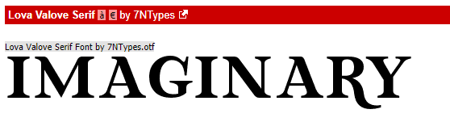

<https://www.dafont.com/lova-valove-serif.font?text=Imaginary&back=theme>

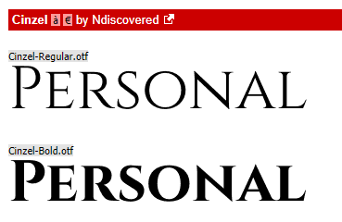

<https://www.dafont.com/cinzel.font?text=Personal&back=theme>

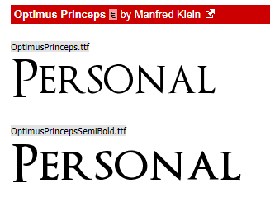

<https://www.dafont.com/optimusprinceps.font?text=Personal&back=theme>

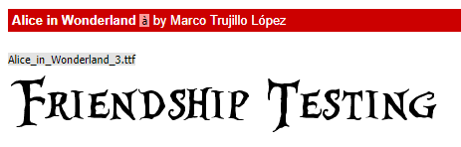

<https://www.dafont.com/alice-in-wonderland.font?text=Friendship+Testing>

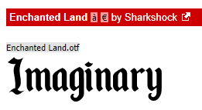

<https://www.dafont.com/enchanted-land.font?text=Imaginary>

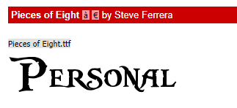

<https://www.dafont.com/pieces-of-eight.font?text=Personal>

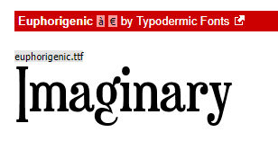

<https://www.dafont.com/euphorigenic.font?text=Imaginary&back=theme>

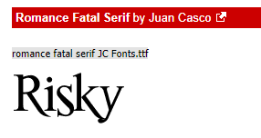

<https://www.dafont.com/romance-fatal-serif.font?text=Risky&back=theme>

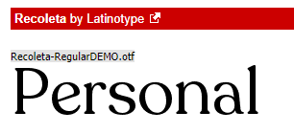

<https://www.dafont.com/recoleta.font?text=Personal&back=theme>